Big Sky Physical Therapy
To insure you receive a complete and thorough evaluation, please provide us with important background information on the following form. If you do not understand the question, your therapist will assist you. Thank you.

HISTORY OF PRESENT CONDITION
- What are your symptoms?

Localize areas of pain or abnormal sensation on the body chart below (Shade in where appropriate)

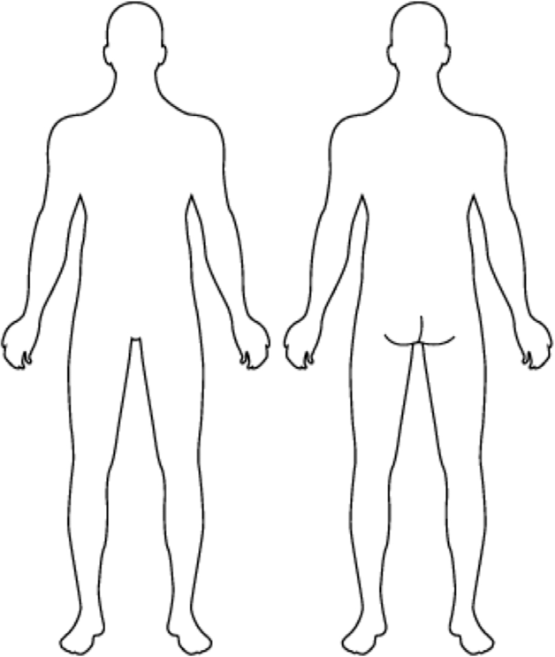
FRONT BACK

- When did your symptoms begin?
(Please indicate a specific date if possible)
On a scale from 1-10 please indicate your level of pain?
(0 being“no pain” and 10 being“worst pain imaginable”)
- Was the onset of this episode gradual or sudden? (check one)
n gradual n sudden
- Which of the following best describes how your injury occurred?
(if your condition is post-surgical please indicate as per original injury)
n lifting n a blow to the face
n a MVA (car accident) n being hit by a ball
n a fall n a dental appointment
n overuse (cumulative trauma) n throwing
n trauma n an incident at work
n degenerative process n unknown
n during recreation/sports n other
n running
- Since onset, are your symptoms getting: (check one)
n better n worse n not changing
- Have you had similar symptoms in the past?
n Yes n No More than one episode? n Yes n No
- Nature of pain/symptoms (check all that apply)
n sharp n aching n constant
n dull n periodic n other
n throbbing n occasional
- As the day progresses, so your symptoms: (check one)
n increase n decrease n stay the same

PATIENT QUESTIONNAIRE
Name: Date: Age: Weight: Height:
- Does the pain wake you at night? n No n Yes if “yes”, is it present n while lying still
n only when changing positions
n both
- Do you have pain/stiffness upon getting out of bed in the morning?
n Yes n No
- In what position do you sleep? (check all that apply)
n right side n back n other
n left side n chair/recliner
n stomach n back, sides, stomach
- Since the onset of your current symptoms have you had: n any difficulty with control of bowel or bladder function n fever/chills
n any numbness in the genital or anal area
n numbness
n any dizziness or fainting attacks
n weakness
n unexplained weight change
n night pain/sweats
n malaise (vague feeling of bodily discomfort)
n problems with vision/hearing
n none of the above
- What aggravates your symptoms? (check all that apply)
n | sitting | n | repetitive activities
n | going to/rising from sitting | n | lying down
n | household activities | n | walking
n | up/down stairs | n | standing
n | reaching overhead | n | squatting
n | reaching in front of body | n | sleeping
n | reaching behind back | n | coughing/sneezing
n | reaching across body | n | taking a deep breath
n | talking, chewing, | n | looking up overhead
 | yawning, all (circle one) | n | swallowing
n | recreation/sports including | n | stress
 |  | n | sustained bending
 |  | n | other
- What relieves your symptoms? (check all that apply)
n sitting n rest n massage
n heat n standing n medication
n cold n walking n nothing
n stretching n exercise n other
n wearing a splint/orthosis n lying down
- Have you had any previous treatment for this condition? (check all that apply)
n none n physical therapy
n medication (oral) n hypnosis
n joint manipulation n biofeedback
n exercise n TENS unit
n massage therapy n acupuncture
n traction n bed rest
n bracing/taping n overnight hospitalization
n injection into spine n casting
n injection into skin/muscles n other

- Have you had any of the following tests?
n none n Arthrogram n TENS unit
n x-rays n biofeedback n Vestibular
n CT Scan n Bone Scan n other n MRI n Stress x-ray Test Results:

MEDICATION
Please list any prescription medications you are currently taking
(pain pills, injections and/or skin patches, etc.):

Prescribing MD: Phone: Are you currently taking any of the following over the counter medications?
n aspirin n vitamins/mineral supplements
n Tylenol n Advil/Motrin/ibuprofen
n corticosteroids n other
n antihistamines

PREVIOUS FUNCTIONAL LEVEL
n Independent in all activities
(work, community, home, recreation)

Self-care
n Independent in all self-care activities (bathing, toileting, dressing, etc.)
n Difficulty performing self-care activities n Need assistance with self-care activities n Difficulty performing household chores Social
n Need assistance with activities in community outside of home

Hobbies:
CURRENT FUNCTIONAL LEVEL
n Independent in all activities
(work, community, home, recreation)

Self-care
n Independent in all self-care activities (bathing, toileting, dressing, etc.)
n Difficulty performing self-care activities n Need assistance with self-care activities n Difficulty performing household chores Social
n Need assistance with activities in community outside of home

Hobbies:
WORK HISTORY
Occupation
n employed full-time n student
n employed part-time n retired
n self employed n unemployed
n homemaker n other
Physical activities at work (check all that apply)
n sitting n computer use
n standing n heavy equip. operation
n phone use n driving
n repetitive lifting n other
n heavy lifting
Are you currently receiving or seeking disability for this condition?
n Yes n No
If not performing your normal activities at work do you plan to RETURN to your previous activity level?
n Yes n No

LIVING SITUATION
n live alone n home/apartment
n live with family members n assisted living complex
n live with caregiver n other
n retirement complex

Setting:
n stairs (railing) n no stairs n uneven ground
n stairs (no railing) n ramp n elevator
n other

GENERAL HEALTH
How would you rate your average health?
n Excellent n Average n Poor
n Good n Fair
Do you use exercise outside of normal daily activities? n 5+ days/wk n 1-2 days/wk n zero n 3-4 days/wk n occasionally
Recreation activities consisting of:
n running n golfing n walking
n biking n tennis n skiing
n swimming n other
Do you drink caffeinated beverages?
n No n Yes How many/much per day
Do you smoke?
n No n Yes Packs of cigarettes per day
What is your stress level?
n Low n Medium n High
Are you seeing any health care providers other than the physical therapist for this current condition? (please list)

PAST MEDICAL HISTORY
Have you ever had/been diagnosed with any of the following condition? (check all that apply)
n Cancer (type) n Heart problems
n Depression n High blood pressure
n Stroke n Lung problems
n Kidney problems n Blood disorders
n Thyroid problems n Epilepsy/seizures
n Diabetes n Allergies
n Multiple sclerosis n Rheumatoid arthritis
n Arthritis n Osteoporosis
n Head injury n Broken bone
n Stomach problems n Circulation/vascular problems n Parkinson’s disease n other n Infectious disease
(i.e. Hepatitis, Tuberculosis, etc.)
Please list any past surgeries related to you current problem:
SURGERY DATE

FAMILY HISTORY
Has anyone in your immediate family (parents, brothers, sisters) ever been treated for the following?
n Diabetes n Cancer
n Heart disease n Arthritis
n High blood pressure n Osteoporosis
n Stroke n Psychological condition
n Other

